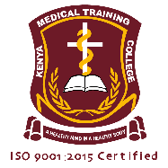
INTERNAL MEMO
To: All Students
From: School Administration
Date: 29th September 2025

Subject: Mandatory Clearance of School Fees and COC Examination Fee

This serves as the final warning to all students with outstanding school fees and COC examination fees.
All balances must be cleared in full by 17th October, 2025 without exception.

Be advised that:
Any student with outstanding fees will be suspended immediately after the deadline.
No student with arrears will be allowed to attend classes, access school facilities, or sit for any examinations, including the COC exam.
Results, transcripts, and certificates will be withheld until all fees are cleared.

The administration will not entertain excuses or late payments. Failure to comply will result in serious academic and administrative consequences.
We expect strict adherence to this directive.

Regards
Hudson Shinali
HOD Clinical Medicine

